

Rest & Message Based Services

Charles Henderson



April 15, 2019

CST-235

Jackson

6: web.xml configuration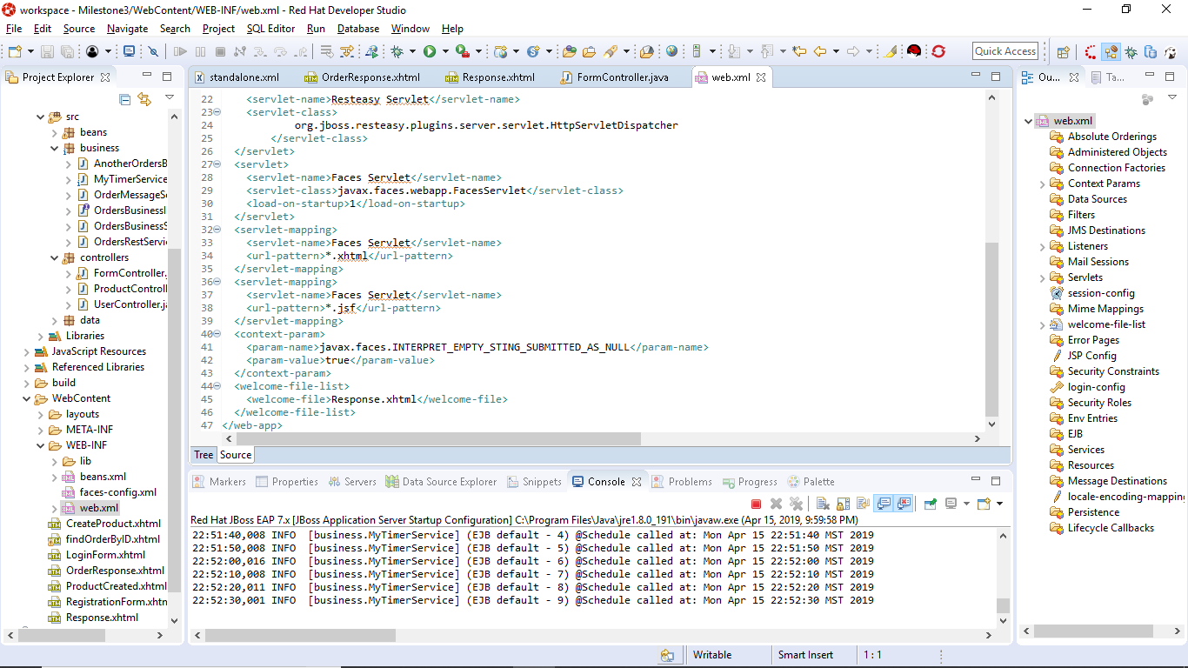

6: Orders Rest Service:

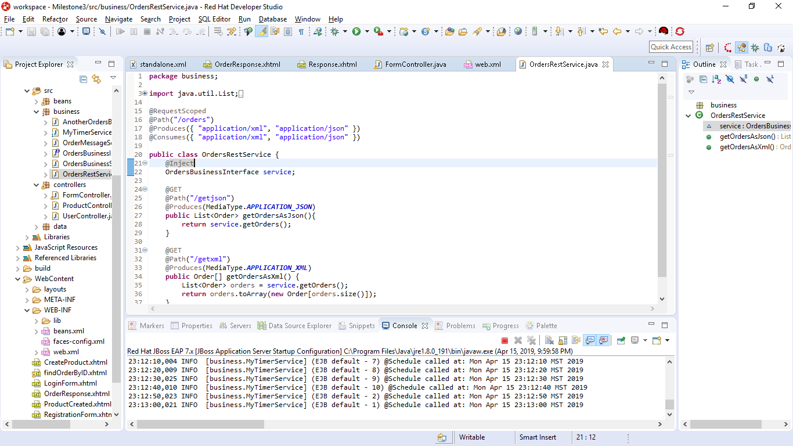

JSON in firefox:

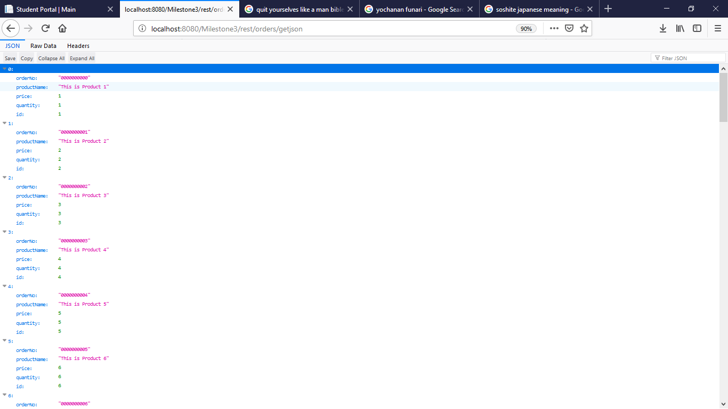

Standalone xml configuration: 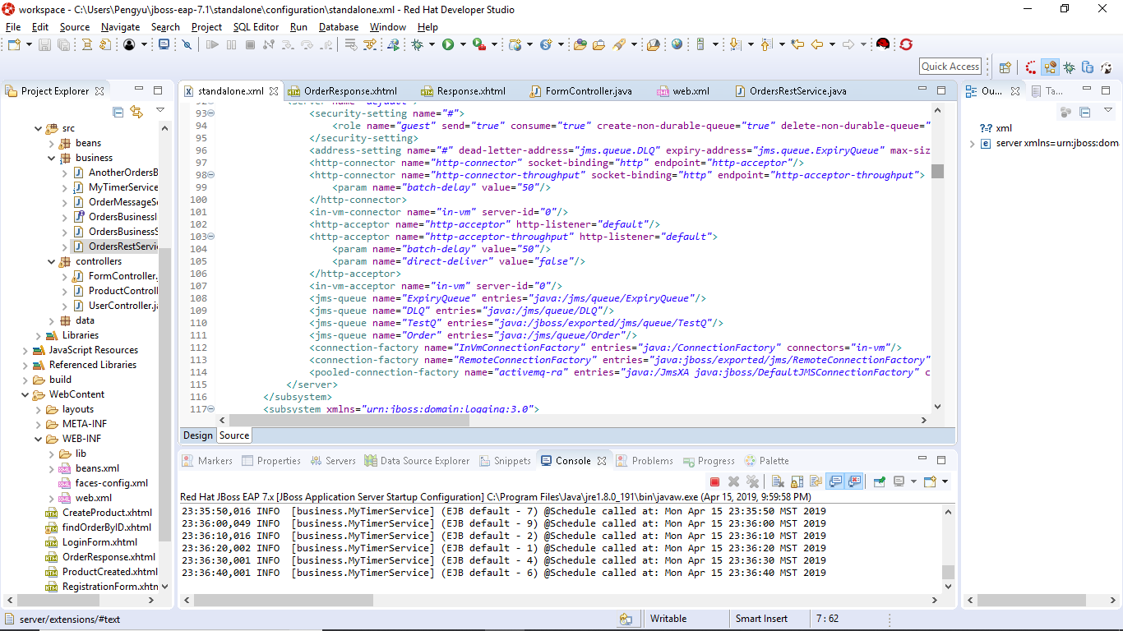

Message Driven Bean: 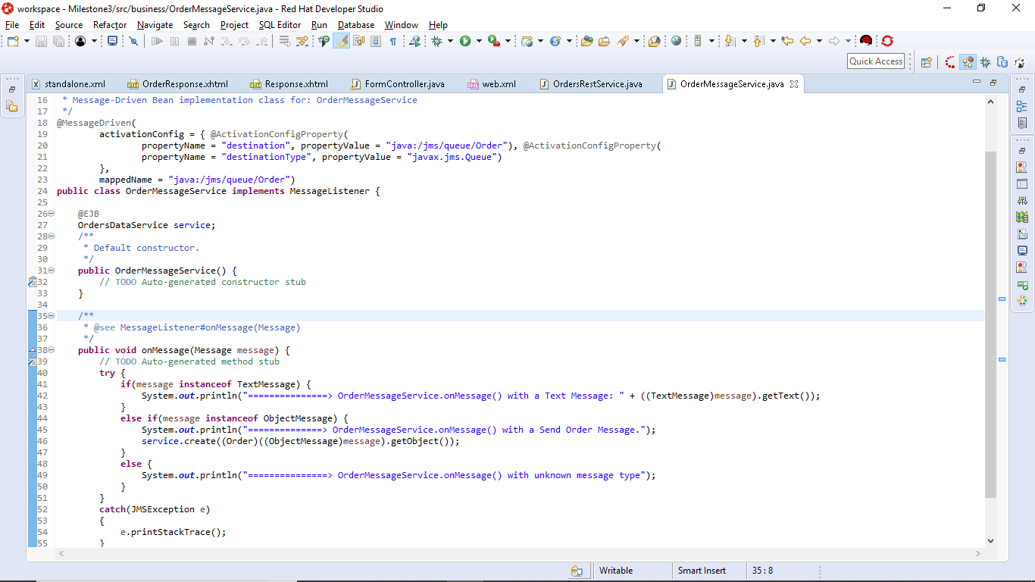

Orders Business Service send Order method: 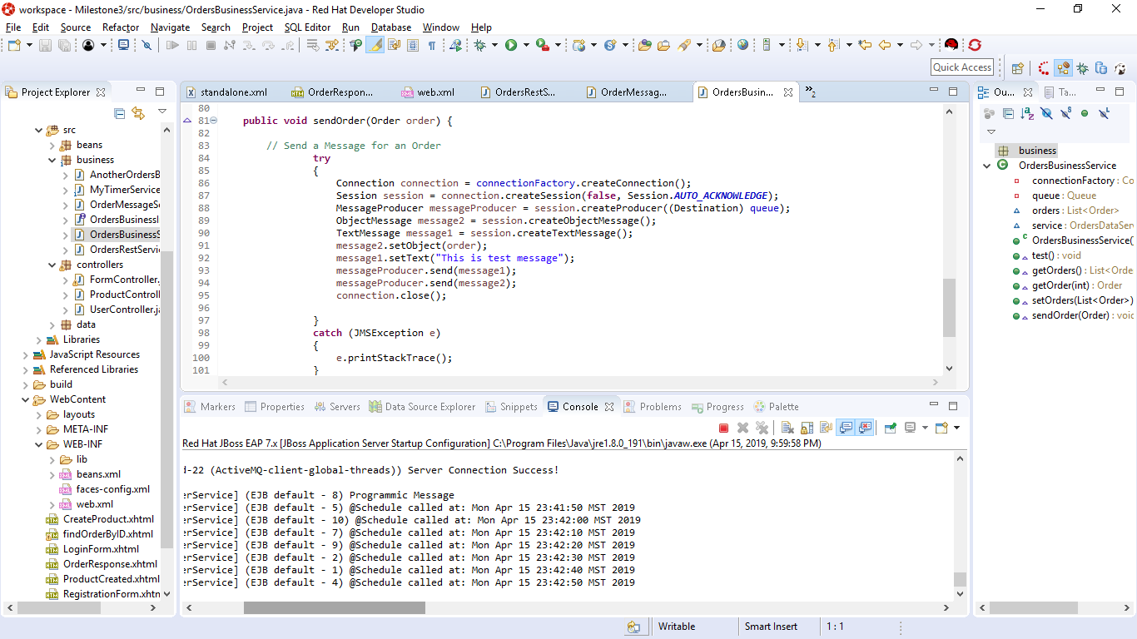

Output in Console: 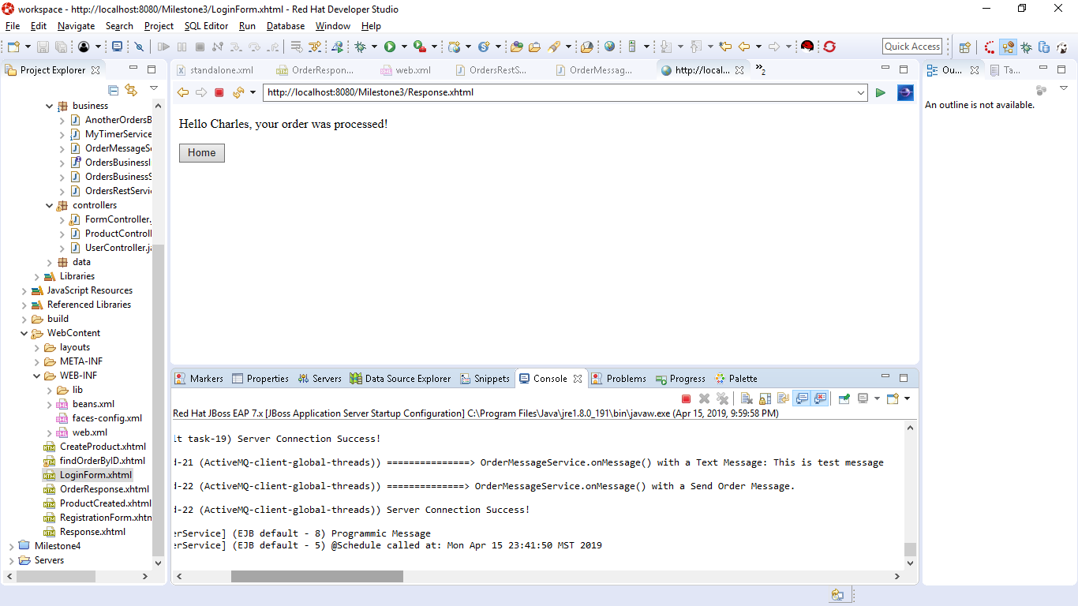

You can then go back and see the latest addition to the order list: 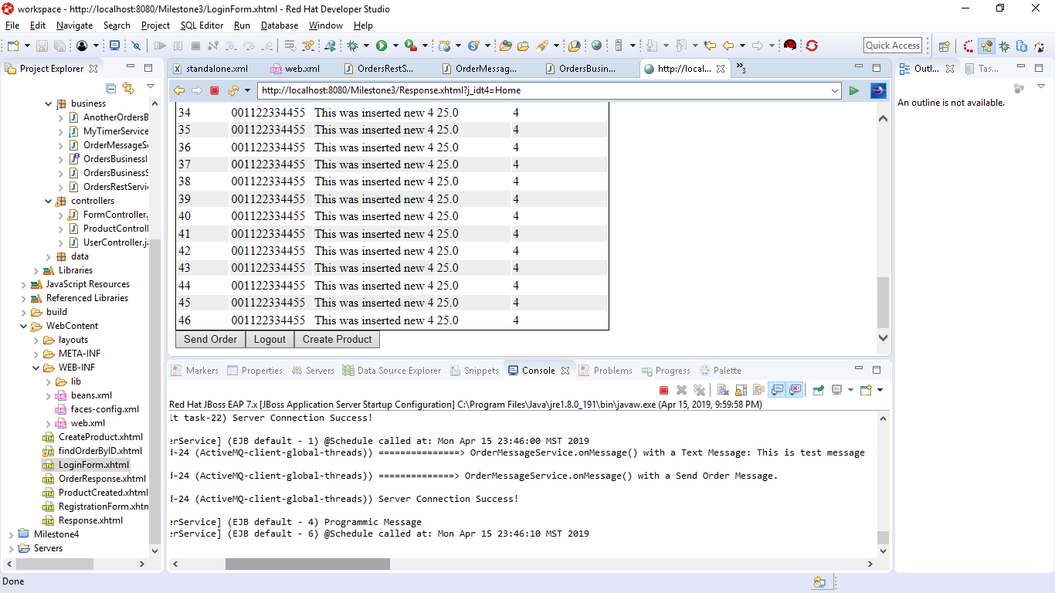

Brief Theory of Operation:

Rest API’s are a protocol that are designed to utilize http and organize the output of information. It’s ease of use and dependable structure allow for a literal pretty print of data which can then be parsed and manipulated as you see fit. For this particular activity we are simply using it to display the order that we have for our application. In the in-class activity we utilize a few more of Java’s built in functions like the message driven and rest api’s. This is done by creating their own classes and functions within the business layer. This of course is activiated by the form controllers on send method which calls the interfaces methods. The interface send order method then takes the order and generates the messages in the console verifying the addition of the order to your list. You can then go back to the order response page and see the order in the generated data table.